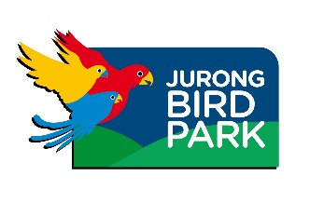
Songbird Crisis Summit:

Setting Priorities to Address the Threat of Songbird Trade in the Greater Sunda Region
26th-29th September 2015, Jurong Bird Park, Singapore

SUMMIT REGISTRATION FORM

Please fill in the appropriate details for the Summit and return this form by email to Jessica Lee at jessica.lee@wrs.com.sg by Saturday the 1st August 2015.

Participant Details
Title |  | First Name |  |  | Last Name
Affiliation
Position |  |  |  | Section (if relevant)
Address
City/Country
Email Address
Phone Number

Please provide details of your stay:

Date of Arrival: Date of Departure:

Accommodation Details:

Contact Details in Singapore (if different to above):

If you’ll be taking part in the Summit meals and dinner, please indicate any dietary preferences or allergies (e.g. vegetarian, gluten-free etc…)

Please note that as this is a strategy-planning workshop, sufficient knowledge on the topic as well as active participation in the development of this conservation strategy document is expected. In order to facilitate this process, please address the questions below in a few sentences.

- Your area of expertise
- How you can contribute to the Summit Workshop?
- What are your interests in attending this Summit Workshop?
- What you hope to achieve from this Summit Workshop?

For any other queries, contact Jessica Lee at jessica.lee@wrs.com.sg or +65 98226644.
